Interfacing of 8051 with (i2c based) 24LC64 EEPROM (code + Proteus simulation)
This post provides the code for interfacing 24LC64 EEPROM with 8051 microcontroller (e-g AT89C51 or AT89C52 etc). This 24LC64 EEPROM has i2c based interface and 8051 doesn't have any built in i2c modules, so software i2c module is created in the code. This code is written in C language using Keil uvision4 compiler. You can download this code from the 'Downloads' section at the bottom of this page.
It is assumed that you know how to interface LCD with 8051 microcontroller in 4bit mode. If you don't then please read this page first, before proceeding with this article. It is also assumed that you know how to create software i2c module in 8051, if you don't then please read this page first. You should also read how to write/read a byte in/from 24LC64 EEPROM from it's datasheet.
The result of simulating the code in Proteus is shown below.
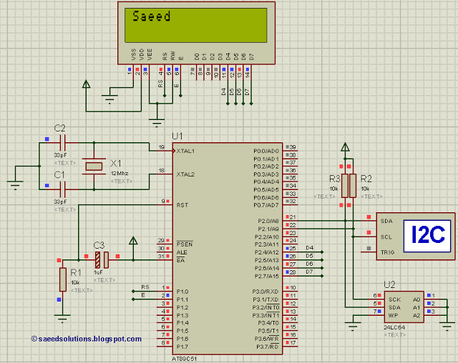
Figure 1. Interfacing 24LC64 EEPROM with 8051
In the above circuit^{[1]}, P2.0 pin is being used as SDA pin and P2.1 pin is the SCK pin. Both of these pins are pulled up using 10K resistors as required for i2c protocol. 24LC64 EEPROM is the slave device, while 8051 is configured to be the master. LCD is also attached with 8051, just to show the values received from the EEPROM, otherwise it is not required in this circuit. Proteus provides an 'I2C Debugger Tool' which is attached on the SDA and SCK pins in the above circuit, this debugger shows all the activity on i2c bus^{[2]}. It is attached in the circuit just for debugging purposes.
In the code, string 'Saeed' is stored in the 24LC64 EEPROM and then retrieved back and displayed on the LCD. As shown in Figure 1, 'Saeed' is correctly displayed on the LCD, this shows that it was stored and retrieved from 24LC64 EEPROM successfully.

Code
The code for the main function is shown below.
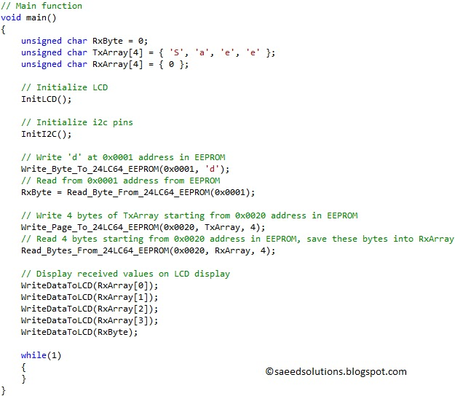
Figure 2. Main function code for interfacing 8051 with 24LC64 EEPROM
In the main function, firstly LCD is initialized using InitLCD() function. Then i2c pins are initialized using InitI2C() function. Then Write_Byte_To_24LC64_EEPROM(0x0001, 'd'); function writes 0x64 (i-e 'd') value on 0x0001 address in the EEPROM. After that, Read_Byte_From_24LC64_EEPROM(0x0001); function reads a single byte from 0x0001 address and saves this value in RxByte variable.
Write_Page_To_24LC64_EEPROM(0x0020, TxArray, 4); function writes 4 bytes present in the TxArray starting from address 0x0020. And Read_Bytes_From_24LC64_EEPROM(0x0020, RxArray, 4); function reads 4 bytes from the starting address of 0x0020 and saves these bytes in RxArray. In the end all of these 5 received bytes are displayed on the LCD. You can verify from Figure 1, that all of these bytes were correctly received and displayed on the LCD. Using these simple read and write functions you can easily interface 24LC64 EEPROM with 8051.
Write_Byte_To_24LC64_EEPROM() function code is shown below.
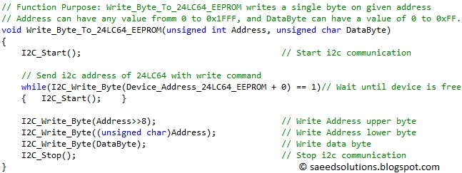
Figure 3. Write byte to 24LC64 EEPROM code
In Write_Byte_To_24LC64_EEPROM() function, firstly i2c start bit is sent. Then i2c address of 24LC64 EEPROM is sent along with start bit, again and again until an ACK is received from 24LC64 device indicating that it is not busy. After it is ensured that slave 24LC64 is not busy, Address bytes are sent. And then the data value (which will be written on the given address in EEPROM) is sent. In the end stop bit is sent. After receiving stop bit, 24LC64 EEPROM starts to store DataByte value at the given Address in it's internal storage. Address can have a value from 0x0000 to 0x1FFF only, also DataByte can have a value from 0x00 to 0xFF only.
Read_Byte_From_24LC64_EEPROM() function code is shown below.
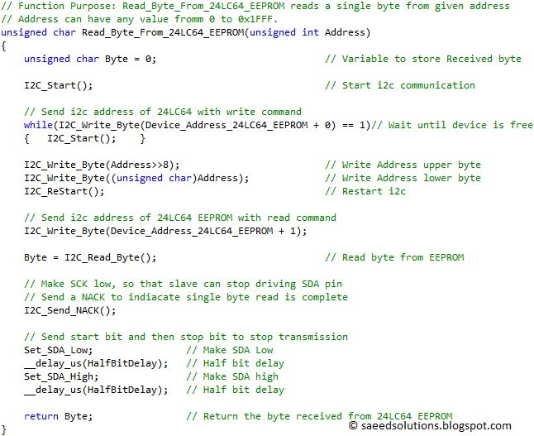
Figure 4. Read byte from 24LC64 EEPROM code
Read_Byte_From_24LC64_EEPROM() function reads a single byte from 24LC64 EEPROM from the given Address. Address can have a value in between 0x0000 to 0x1FFF only. In the function code firstly i2c start bit is sent. Then i2c address of 24LC64 EEPROM is sent along with start bit, again and again until an ACK is received from 24LC64 device indicating that it is not busy.
After it is ensured that slave 24LC64 is not busy, Address bytes are sent. In this way, correct address is sent to 24LC64 EEPROM, then i2c start bit is sent again using I2C_ReStart() function. Then read command is sent. 24LC64 EEPROM sends back byte value from the current address, which is saved in the variable named Byte. After that a NACK and a stop bit is sent to 24LC64 EEPROM to stop reading any further bytes. In the end, received byte value is returned from the function.
The code for Write_Page_To_24LC64_EEPROM() function is shown below.
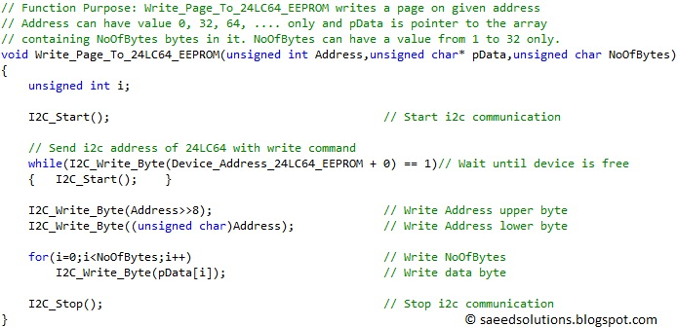
Figure 5. Write Page to 24LC64 EEPROM code
Write_Page_To_24LC64_EEPROM() function writes NoOfBytes bytes from an array (pData is pointer to that array) in 24LC64 EEPROM at the given starting Address. This function can at most write a page (i-e 32 bytes) in 24LC64 EEPROM. To write more than 32 bytes, you have to call this function multiple times in your main code. The reason for this restriction is that, 24LC64 EEPROM can write only a single page at a time in it's internal storage. So, here Address variable can have a value only in multiple numbers of 32, i-e 0x0000, 0x0020, 0x0040, 0x0060 etc up to 0x1FDF only. And NoOfBytes variable can have a value in between 1 to 32 only.
For example, in the main code Write_Page_To_24LC64_EEPROM(0x0020, TxArray, 4); statement writes 4 bytes from TxArray at the starting address of second page (i-e 0x0020) in 24LC64 EEPROM.
Inside Write_Page_To_24LC64_EEPROM() function, firstly i2c start bit is sent. Then i2c address of 24LC64 EEPROM is sent along with start bit, again and again until an ACK is received from 24LC64 device indicating that it is not busy. After it is ensured that slave 24LC64 is not busy, Address bytes are sent. And then the each data byte value is sent one after another. In the end stop bit is sent. After receiving stop bit, 24LC64 EEPROM starts to store received byte values starting from the given Address in it's internal storage.
The code for Read_Bytes_From_24LC64_EEPROM() function is shown below.
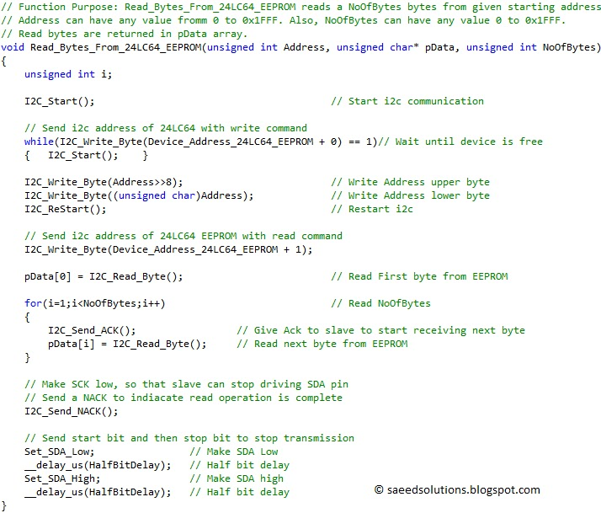
Figure 6. Read Bytes From 24LC64 EEPROM code
Read_Bytes_From_24LC64_EEPROM() function reads NoOfBytes bytes from the given starting Address. NoOfBytes variable can have any value from 0 to 0x1FFF. Also, starting Address can have any value from 0x0000 to 0x1FFF. Read bytes are returned from the function in the pData array.
For example, in the main code Read_Bytes_From_24LC64_EEPROM(0x0020, RxArray, 4); statement reads 4 bytes from the starting address of 0x0020 and stores these bytes in RxArray.
Inside Read_Bytes_From_24LC64_EEPROM() function, firstly i2c start bit is sent. Then i2c address of 24LC64 EEPROM is sent along with start bit, again and again until an ACK is received from 24LC64 device indicating that it is not busy. After it is ensured that slave 24LC64 is not busy, Address bytes are sent. In this way, correct address is sent to 24LC64 EEPROM, then i2c start bit is sent again using I2C_ReStart() function. Then read command is sent. 24LC64 EEPROM sends back byte value from the current address, which is saved in pData[0]. After that an ACK is sent to receive next byte from 24LC64 EEPROM. In this way, all the bytes are read and stored in pData array. After that, a NACK and a stop bit is sent to 24LC64 EEPROM to stop reading any further bytes.
You can leave your comments and suggestions in the comment section below.

Notes and References
^{[1]} In this circuit, 8051 is running at 1 MIPS speed using 12MHz crystal.
^{[2]} 'I2C Debugger Tool' receives all the i2c messages and displays them on the 'I2C Debug' window. This 'I2C Debug' window is shown below in the figure.
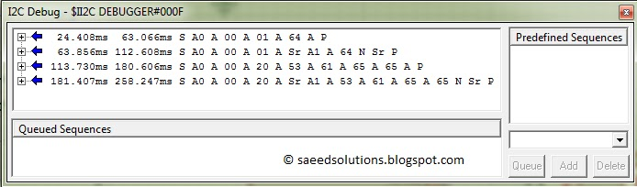
Figure 7. I2C Debug window
In the above figure, 'I2C Debugger Tool' is telling us that there were 4 sequences on the i2c bus. First sequence "S A0 A 00 A 01 A 64 A P" is explained below.
- S is the starting bit sent from 8051(master) to 24LC64(slave).
- Then 0xA0 is sent to slave, this is the address of 24LC64 EEPROM (As mentioned in it's datasheet). Also, LSB bit of 0xA0 is zero, which means it is a writing command for the slave. Slave sends an ACK after receiving this byte.
- Then 0x00 is sent to slave, this is the upper byte of the address in 24LC64 EEPROM on which we want to write a byte. Slave sends an ACK after receiving this byte.
- Then 0x01 is sent to slave, this is the lower byte of the address in 24LC64 EEPROM on which we want to write a byte. Slave sends an ACK after receiving this byte.
- Then 0x64 (it is the value of 'd' character) is sent to slave, this is the value we want to save in 24LC64 EEPROM on the previously given address. Slave sends an ACK after receiving this byte.
- Then a stop bit (P) is sent to slave. Slave starts it's internal process of saving 0x64 value at 0x0001 address, which takes about 5msec.
- If you disturb slave when it is busy, then it will send you a NACK to indicate that it is not available. So, you have to keep sending it starting bit and address byte and when slave finally sends an ACK, then you can send rest of the command to it.
Only the first sequence is explained above, but you can easily understand remaining 3 sequences using the same approach as described above.

Downloads
The code was compiled in Keil uvision4 and simulation was made in Proteus v7.10.
To download code and Proteus simulation click here.

Further Reading Suggestions
You may also like,
- 8051 i2c (bit banging) code + Proteus simulation
- 8051 LCD Interfacing code (In 4bit mode) + Proteus Simulation
- Interfacing with UART of 8051 controller
- 8051 simple calculator c code + proteus simulation
Posted 8th November 2012 by Saeed Yasin
Labels: 8051 micro-controller Projects

